**PROJECT NAME-**

**ILLUMINATING INSIGHTS FROM UBER EXPEDITIONARY ANALYSIS**

**TEAM MEMBERS** ***– INDUMATHI S***

***KAVITHA V***

***KAVYA M***

***KEERTHANA M***

1. **INTRODUCTION:**

***OVERVIEW ABOUT UBER***:

Uber is a multinational transportation network company that operates a ride hailing platform. It drives analysis refers to the analysing the number of trips taken by uber drivers can provide insights into their overall activity and the demand for rider in specific areas.

***PURPOSE***:

"Illuminating insights from Uber Expeditionary Analysis" likely refers to the extraction of valuable information or findings from an analysis conducted by Uber, potentially for improving operations, making informed decisions, or sharing knowledge with stakeholders. This process aims to shed light on key aspects of Uber's operations or strategies for strategic and operational benefits.

1. **PROBLEM DEFINITION AND DESIGN THINKING**:

***EMPATHY MAP***:

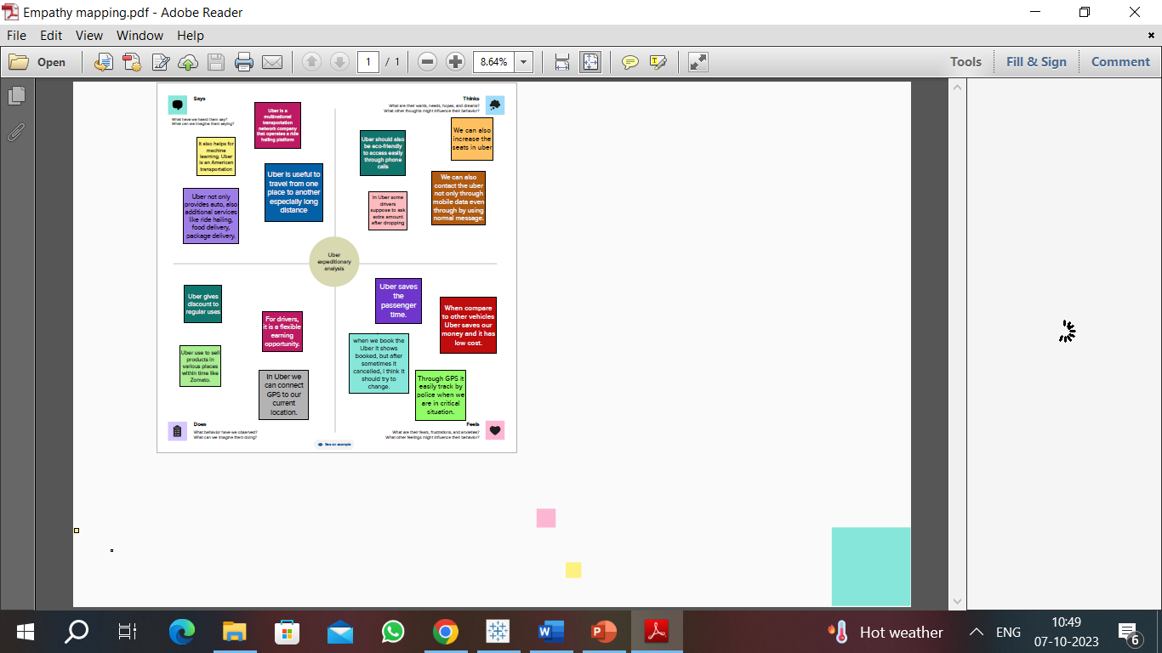

***IDEATION AND BRAINSTROMING MAP:***

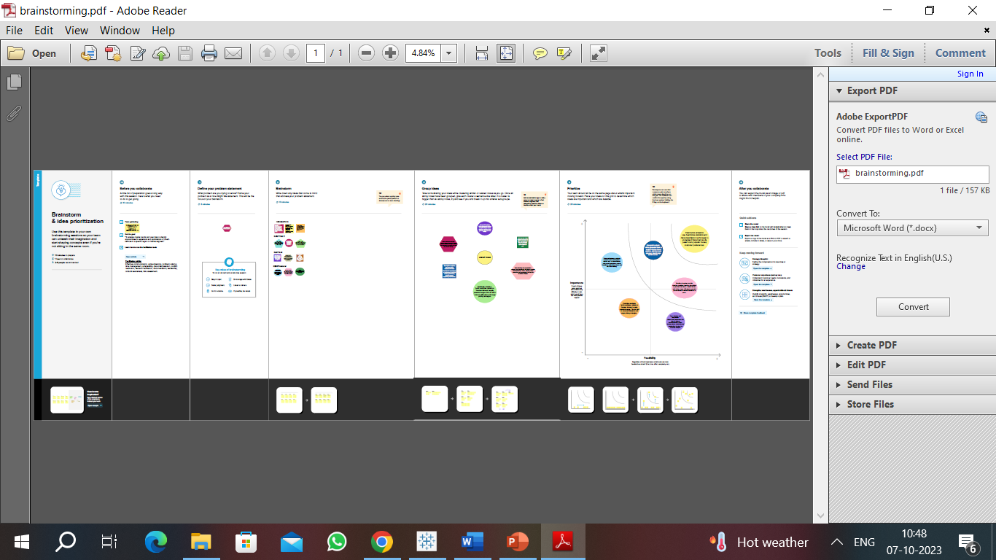

1. **RESULT:**

***DASHBOARD:***

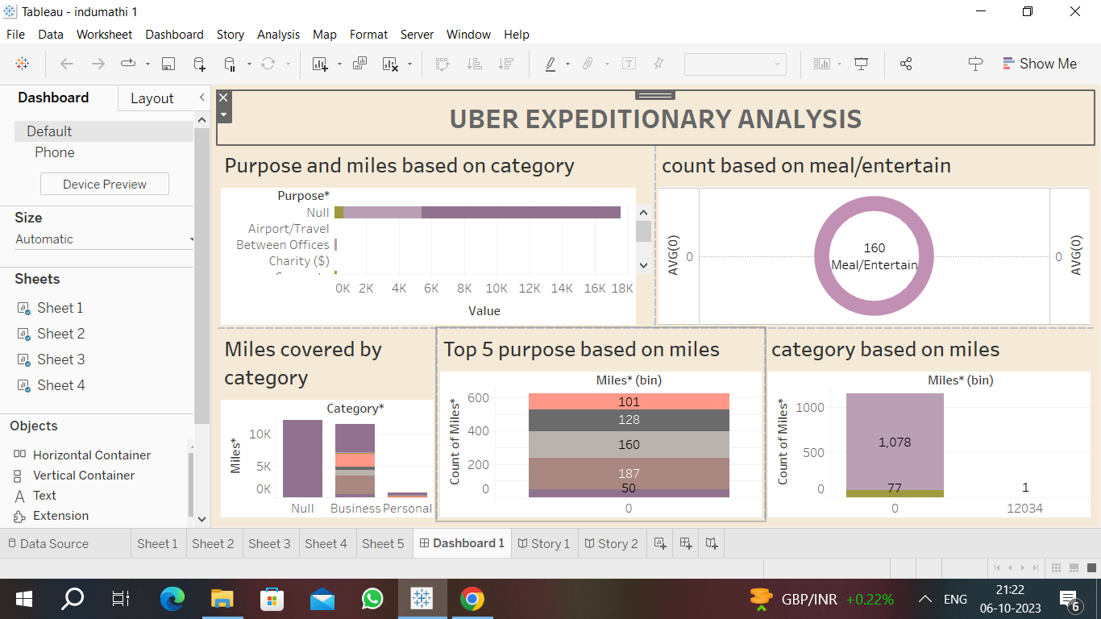

***STORY TELLING***:

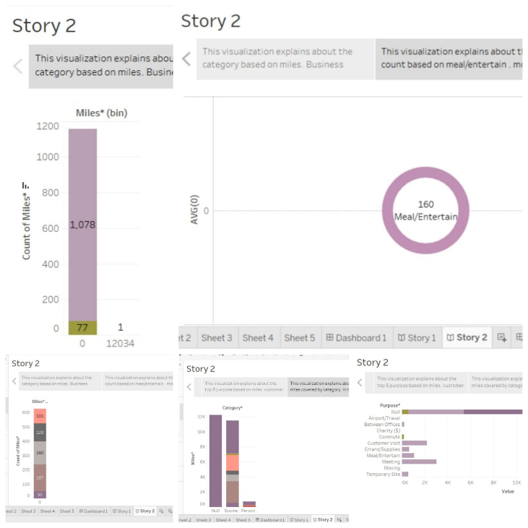

**4.ADVANTAGES:**

Improved Decision-Making

Safety Improvements

Enhanced Customer Experience

Cost Savings

5.**DISADVANTAGES:**

Data Privacy

Complexity

Overreliance

Resistance to Change

Data Quality

6.**APPLICATIONS:**

"Illuminating insights from Uber Expeditionary Analysis" can be applied to optimize driver allocation, reduce rider wait times, and enhance safety by identifying traffic patterns and peak demand areas. This analysis can also inform pricing strategies, improve operational efficiency, and ultimately elevate the overall customer experience in ride-sharing services.

7**.CONCLUSION:**

It holds immense potential for enhancing the efficiency and quality of Uber's services. By leveraging data-driven insights, Uber can make informed decisions, improve safety measures, reduce operational costs, and ultimately provide a better experience for both drivers and riders in the ever-evolving ridesharing industry.

8.**FUTURE SCOPE:**

As technology and data analytics advance, Uber can further refine its operations, implement predictive algorithms for demand forecasting, reduce environmental impacts, and explore innovative services. This analysis will continue to be instrumental in shaping the future of urban mobility and transportation.